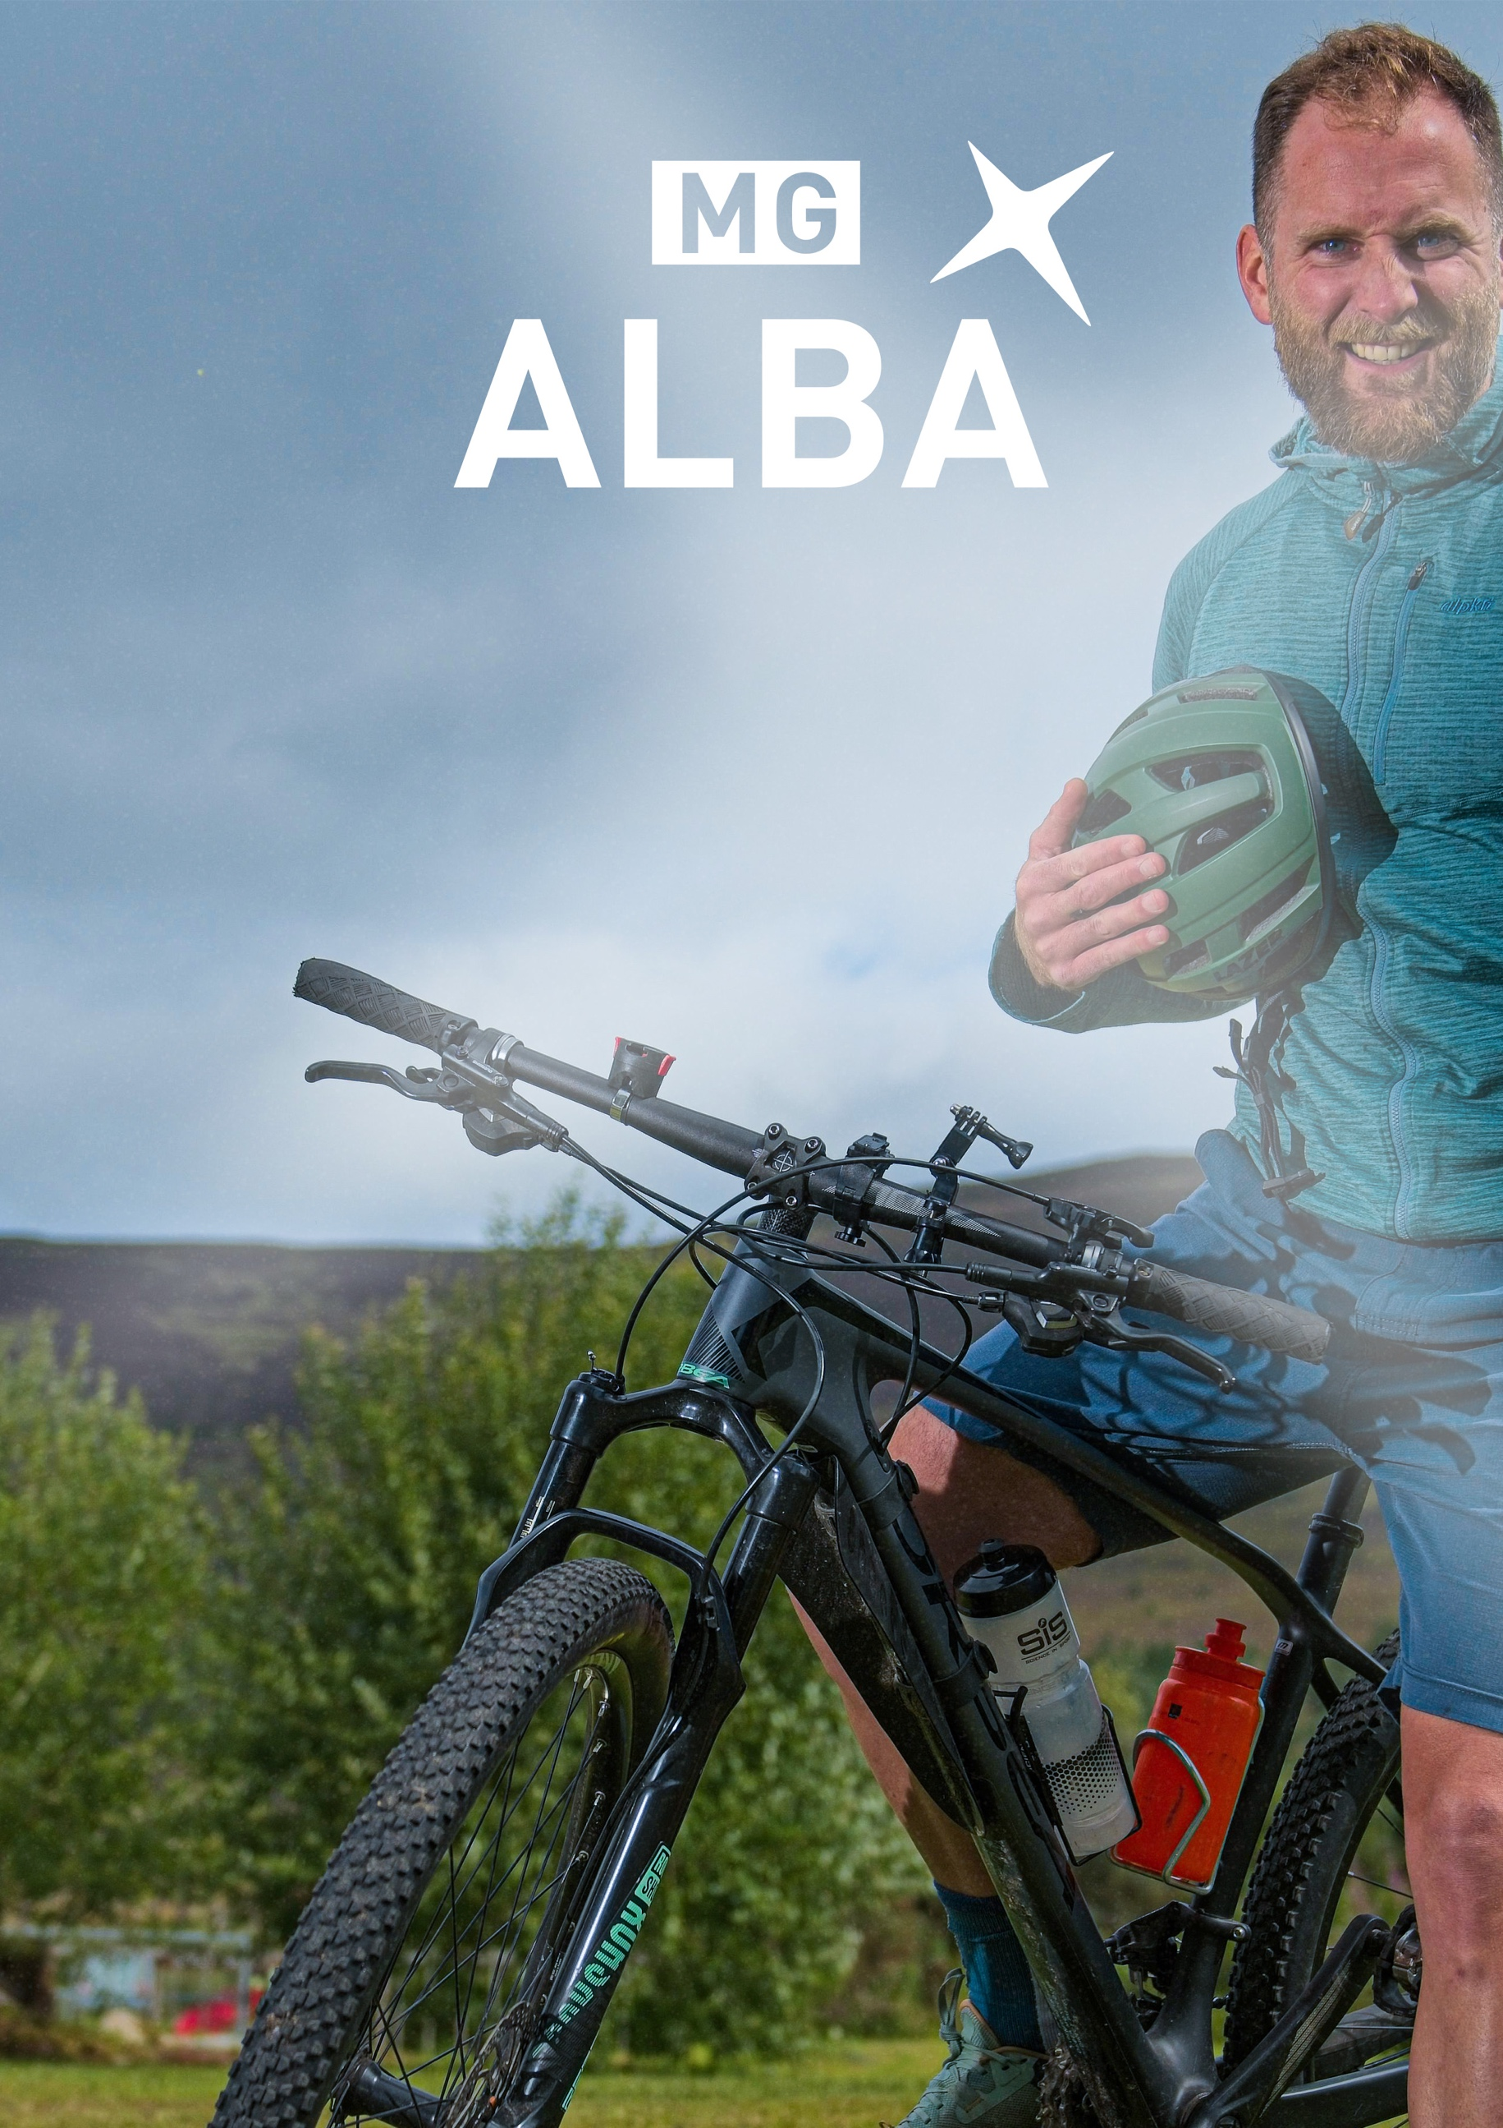

RECRUITMENT PACK

CONTENTS

WELCOME MESSAGE 3

OUR WORLD 4

OUR VALUES 5

JOB DESCRIPTION 6

ADVERTISEMENT AND INSTRUCTIONS FOR APPLICATION 8

A word from our Chief Executive…
We are seeking a Commissioning Executive (Sport) to join our team.

As a Commissioning Executive you will oversee MG ALBA's sports rights portfolio, deliver 180 hours, approximately, of live sport for BBC ALBA's platforms each year, and build strong relationships with rights holders, our production partner, and other broadcasters. You may also be involved in MG ALBA’s wider commissioning processes.

This is a wonderful opportunity to play an integral part in Gaelic media as it transforms to meet the fast-changing needs of our audiences and users.

If you believe this job could be for you, please find within this pack the advert, job description, and application instructions.

If you have any disability, access, or inclusion requirements, please let us know. Our team will be happy to make any reasonable adjustments you need to take part fully in the recruitment process.

We look forward to receiving your application.

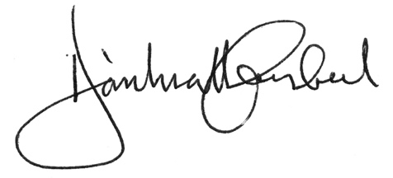
Dòmhnall Caimbeul
19/12/2025

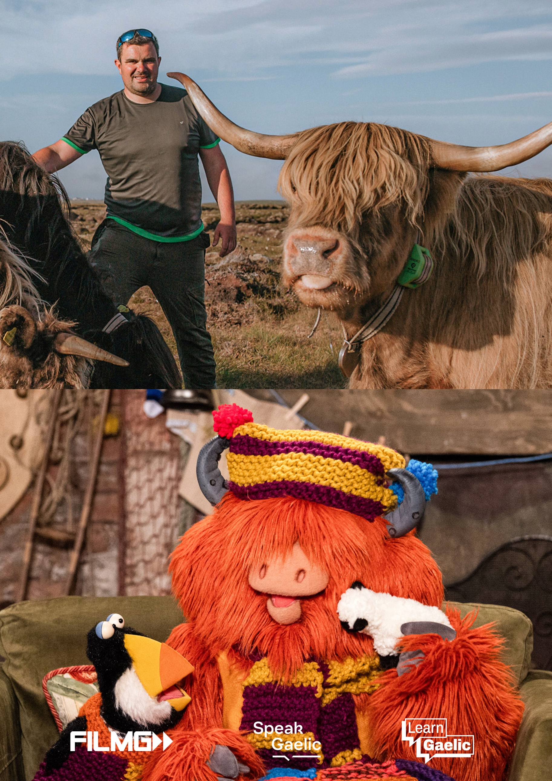
OUR WORLD

GAELIC FOR EVERYONE

WHEREVER YOU ARE

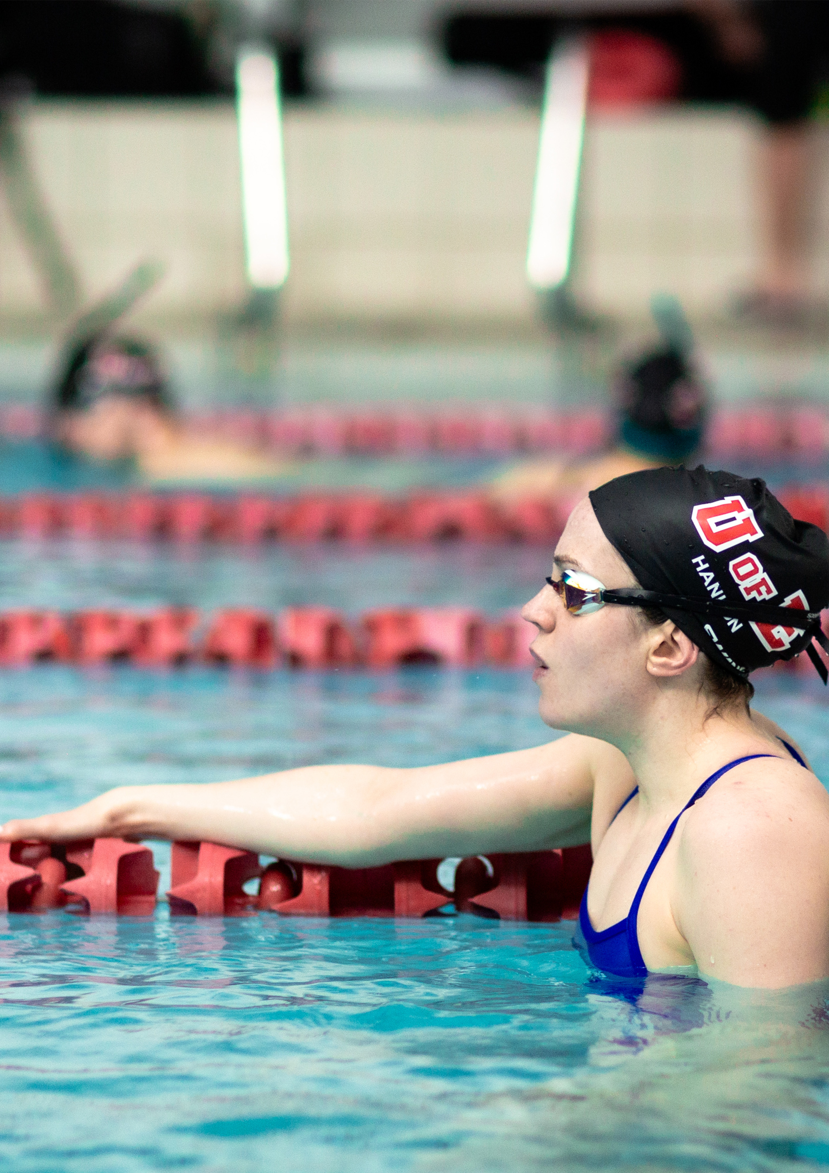

OUR VALUES
CREATIVITY
We enable the creation of high-quality Gaelic content.

AUDIENCE
We are informed and inspired by our audience.

AMBITION
We strive for and deliver excellence.

PARTNERSHIP
We achieve through collaboration.

RESPECT
We listen; we encourage; we are fair.

COMMISSIONING EXECUTIVE (SPORT)

Job Title | COMMISSIONING EXECUTIVE (SPORT) | Grade | E | Weekly Hours | 37
Location  Salary Range | Glasgow/ Stornoway/ Other in Scotland  £56,618 to £59,066
Responsible For | - The effective management and performance of MG ALBA’s portfolio of sports rights.  - Management and delivery of a portfolio of live sport to BBC ALBA from the in-situ independent sports production partner.  - Maintaining and developing relationships with rights holders and other broadcasters and partners.
Accountable to | Director of Content
Working relationships | Internally – BBC ALBA Commissioning Team & MG ALBA Business Affairs Team  Externally – External rights holders, BBC Radio nan Gàidheal, BBC Sport and other external broadcast partners.
Objectives | - To manage the delivery of a portfolio of live sport to BBC ALBA.  - To balance editorial excellence with all rights, compliance, and budgetary requirements.  - To maintain and develop effective relationships with all relevant sports rights holders and with BBC Sport and BBC Radio nan Gàidheal.  - To promote on-screen talent development for BBC ALBA’s sports output.
Key Results | - Delivering impactful and high-quality live output for BBC ALBA leading to increased audiences and engagement.  - Ensuring originality and high-quality levels are consistent across the BBC ALBA sports output.  - Reaching and engaging with new and hard to reach audiences on non-linear platforms.  - Strong relationships with rights holders and other broadcasters and partners.  - Development of new Gaelic-speaking talent in production and on screen, particularly in the area of women’s football output.
Key Tasks | - To act as the key contact for MG ALBA’s sports production partner during the selection of live fixtures and production process for BBC ALBA, offering advice and guidance on BBC ALBA commissioning requirements, and upholding the reputation for quality and high standards.  - To offer input and recommendations to the development of the sports commissioning strategy, including the acquisition of sports rights and spot buys.  - To ensure that live output meets the needs of BBC ALBA’s audience, that content is appropriate for its target age group and reflects the diverse nature and needs of our audiences.  - To ensure that editorial content complies with the BBC’s editorial standards and guidelines, and takes responsibility for ensuring that all activities comply with Safeguarding Trust, Data Protection, Fair Trading and Legal policy.  - Ensure the output from the sports production partner is based on a sound understanding of diversity, cost, quality, rights maximisation and funding needs.  - To ensure that all content is delivered on time and within budget including monitoring progress, anticipating problems and using multiple sources of information to arrive at solutions.  - To manage and build relationships with sports rights holders and collaborate with BBC Sport and BBC Radio nan Gàidheal.  - To manage and nurture relationships with Gaelic language on-screen talent in all its diversity and be aware of and foster new emerging talent.  - To build and maintain a detailed knowledge of the sports rights world, production suppliers and strengthen positive working partnerships inside and outside of MG ALBA and the BBC.  - To provide feedback on pitches and tenders, and any content produced by the sports production partner.  - To support and facilitate BBC ALBA strategies including involvement in BBC and other industry initiatives, including support for language learning initiatives via SpeakGaelic and LearnGaelic.
Core Skills | The post holder should possess the following skill sets and competencies:  - Must have a keen interest and knowledge of sport content as a genre and a proven record in commissioning content or similar transferrable editorial skills.  - Good production knowledge with a proven record of successful programme making or other production experience or experience of media rights acquisition and deal negotiation.  - Fluency in Gaelic.  - Sound editorial judgment and knowledge of BBC editorial policy and fair trading issues.  - A knowledge and passion for maximising opportunities to create multiplatform content, understanding the positive impact and benefits this brings.  - Demonstrable understanding of current trends and issues within the broadcasting industry and specifically in the genre of sport.  - Outstanding communication skills and ability to foster good relationships with a wide range of internal and external contacts.  - Experience in collaborating on multi-partner projects and strong influencing skills and abilities.  - Self-assured, with good team working and leadership skills.  - Excellent planning and organisational skills with the ability to meet deadlines and financial commitments.  - Demonstrable ability to think strategically about content.  - Audience focused in approach, aware of trends, topical issues and gaps in output.  - Evidence of a commitment to creating diverse content and to MG ALBA and the BBC’s diversity strategy and policies.  - Knowledge and understanding of the financial consequences of editorial decisions.  - Development and awareness of new production and on-air talent in particular around women’s football output for BBC ALBA.
Duration | Permanent
Advert
As our Commissioning Executive, you will bring a real passion for sport and strong editorial or commissioning experience. You will know how great sport content is made, from production to rights acquisition, and you will be confident working with partners and negotiating deals.

Fluency in Gaelic is essential, along with sound editorial judgement and a solid understanding of BBC standards.

You will spot multiplatform opportunities and know how sport content can drive audience engagement. You will understand the sports broadcasting landscape, be a good communicator, and build strong relationships. Planning, strategic thinking and an audience-focused mindset will be key to your success.

You will value diverse, authentic content, understand the financial impact of editorial choices, and have a good eye for emerging talent, especially in women’s football for BBC ALBA.
This post carries an expectation of weekend and evening work to monitor television and social media output and attend fixtures and industry events, and a Mon-Fri routine with time off in lieu as appropriate is envisaged.

Alongside a competitive salary, you will also have access to a range of benefits, which include:
- Contributory pension scheme – 10% Employer contributions, additional 5% if matched.
- 31 days annual leave exclusive of 6 days public holidays (pro rata)
- Gym membership opportunities
- Family-friendly & flexible working practices
- Cycle to Work Scheme
- Working for an employer who has been awarded Investors in People (Gold), We Invest in Wellbeing (Standard) and Investors in Young People (Gold)

Closing Date for applicants - Monday 19th January 2026 9am, late applicants will not be accepted.

Instructions for Application:
Please send your CV and covering letter to laura.rennie@mgalba.com explaining why you should be considered and your understanding of how you can successfully fulfil the position.


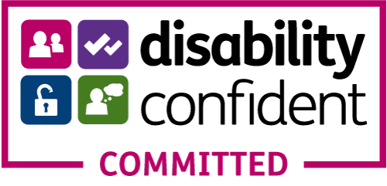
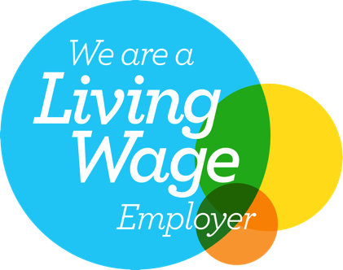
MÒRAN TAING!

