**RECRUITMENT PACK**

**CONTENTS**

WELCOME MESSAGE 3

OUR WORLD 4

OUR VALUES 5

JOB DESCRIPTION 6

SKILLS & EXPERIENCE 8

ADVERTISEMENT AND INSTRUCTIONS FOR APPLICATION 10

***A word from our Chief Executive…***

We have a vacancy for a new Digital Content Strategist to join our team based in our Stornoway office.  This is a new post, with responsibility for content strategy, planning and resourcing for our digital platforms.

This is an opportunity for the right person to join us as our organisation transforms to meet the fast-changing needs of our audiences and users.

It is an exciting time to be part of something worthwhile, truly transformational and create a legacy for our future stakeholders.

Within this pack you will find the advert, the job description, personal specification and instructions for application.

We look forward to receiving your application.

***Dòmhnall Caimbeul***

***28/6/24***

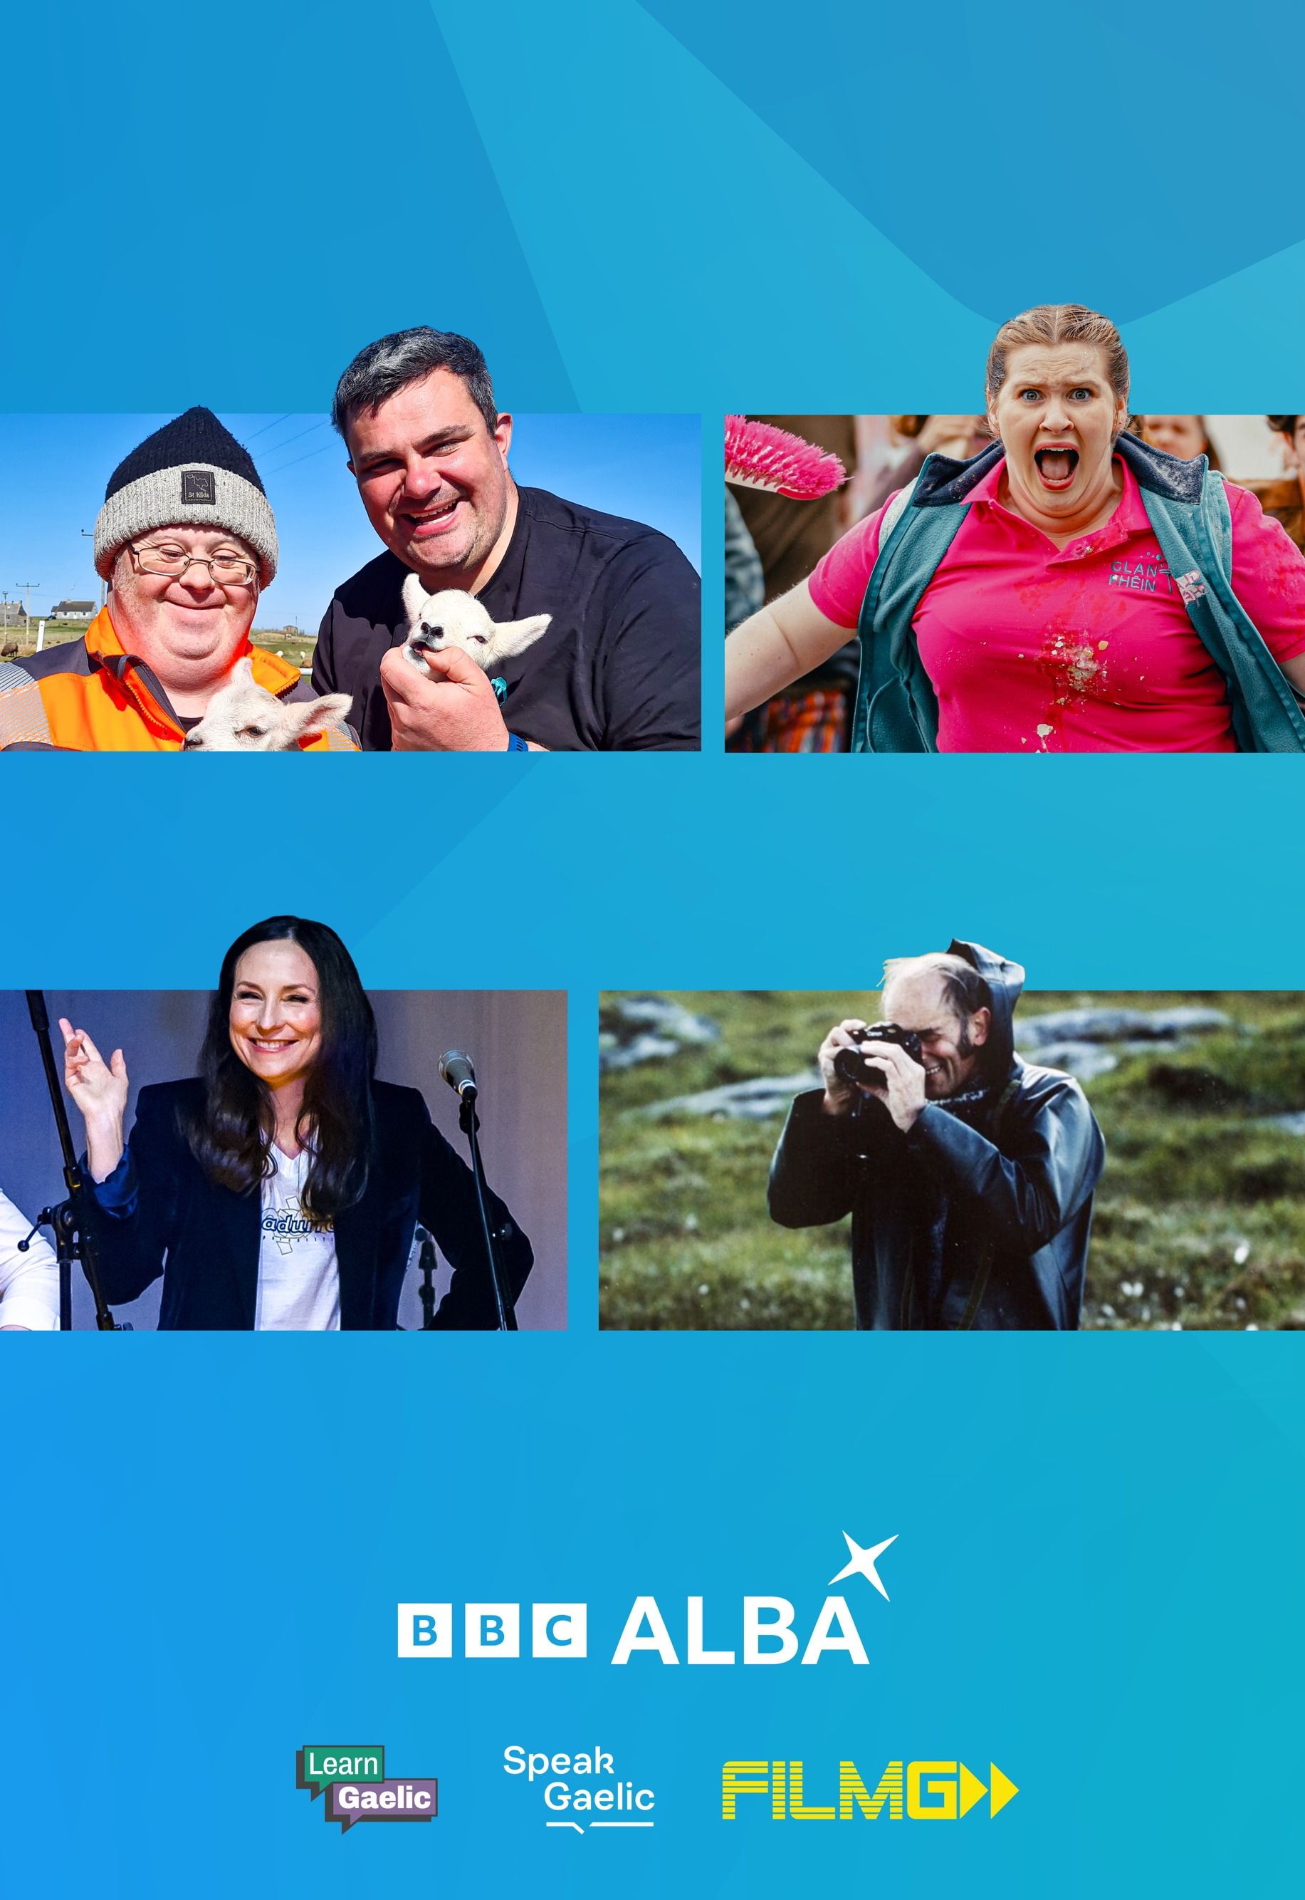**OUR WORLD**

**WHEREVER YOU ARE**

**GAELIC FOR EVERYONE**

**OUR VALUES**

**CREATIVITY**

We enable the creation of high-quality Gaelic content

**AUDIENCE**

We are informed and inspired by our audience

**AMBITION**

We strive for and deliver excellence

**PARTNERSHIP**

We achieve through collaboration

**RESPECT**

We listen; we encourage; we are fair

**Digital Content Strategist**

|  |  |  |  |  |  |
| --- | --- | --- | --- | --- | --- |
| **Job Title** | **Digital Content Strategist** | **Grade** | **D3** | **Weekly Hours** | **37** |
| **Location** | Stornoway with occasional travel | | | | |
| **Purpose** | To be responsible for content planning, strategy and resourcing across all digital platforms (including BBC ALBA’s social media, YouTube, linear) to ensure consistent delivery and publishing of digital assets, by using audience insights and audience trends. | | | | |
| **Salary** | £39,752 - £43,090 | | | | |
| **Accountable to** | Head of Digital Transformation | | | | |
| **Working with** | Internally – Digital content teams, in-house Creatives, Editors, Director of Content, Marketing and Communication teams, Learning team, Presentation, Head of Publishing, and internal technical teams.    Externally – BBC Scotland, Screen Scotland, external suppliers and clients. | | | | |
| **Objectives** | * To connect with audiences across demographics and increase views and engagement. * To manage team efficiently ensuring development in line with business objectives. * To steer audience to BBC ALBA and iPlayer content. * Streamline processes to maximise creative output. | | | | |
| **Key Results** | * Effective year-round Gaelic digital content, in line with agreed marketing plan and priorities. * A motivated and inspired team of creatives and producers, creating engaging, platform-specific output both for promotional purposes and entertainment on digital platforms. * A clear and effective content strategy, continuously developing according to audience insight data. * A clear forward plan and resource management system for platform needs, including internal and external resources. * Increased views and engagement for BBC ALBA’s digital content. * Increased traffic to BBC ALBA and BBC iPlayer content. | | | | |
| **Key Tasks** | 1. Inspire team members to create high quality, engaging content and foster a culture of innovation and creativity. 2. Research trends and utilise audience data to inform digital content strategy and schedule. 3. Continuously review and develop optimisation and improvement plan for digital platforms. 4. Develop, maintain and implement a content calendar to schedule all digital media / marketing assets across platforms: YouTube, social media, web and linear promos. 5. Develop, maintain and implement a calendar for internal and external resource management to increase efficiency in the creation of digital and marketing assets. 6. Brief internal and external suppliers of digital content, in line with marketing / content strategy. 7. Liaise with marketing, digital, publishing and content teams, as well as external suppliers, to ensure delivery of consistent marketing / digital assets to BBC Standards and guidelines. 8. Review and feedback on digital and promotional assets. 9. Liaise with content, digital, comms, presentation and learning team to ensure alignment of marketing and digital content messaging. 10. Ensure published content adheres to BBC Editorial Policy. 11. Effective line management of BBC ALBA digital team.  Working with senior colleagues and team members to identify, review and develop business objectives.  Supporting team members to meet these objectives. 12. Coordinating media management, compliance and music reporting for all digital and promo assets. 13. Commits enthusiastically to line management, professional development, objective setting and performance appraisals. 14. Stay up to date with latest digital and user experience (UX) trends and best practice. | | | | |
| **Duration:** | 2 years’ fixed term with 6 month’s successful probationary period. | | | | |

**Skills and Experience**

|  |  |  |
| --- | --- | --- |
|  | **Essential** | **Desirable** |
| **Qualifications / experience** | * At least 3 years’ experience in a senior role in end-to-end production * Previous digital content experience * Experience in running a team and managing external suppliers | * Previous management experience * Production management or producer experience * Experience in digital marketing. |
| **Language requirement** | * Fluent Gaelic speaker |  |
| **Skills** | * Ability to set objectives and get the best out of a team. * Proven experience of line management. * Project management skills. * Strong attention to detail. * Excellent organisational and planning skills. * Excellent interpersonal and communication skills. (verbal and written). * Editorial mindset. * Basic budget management * Storytelling skills, including basic copywriting and editing. | * Experience with Adobe Creative Cloud, particularly Premiere Pro, Illustrator and Audition. * Experience with project management software and implementing new processes. |
| **Knowledge** | * Understanding of MG ALBA’s purpose. * Practical knowledge of digital and social media platforms. * Ability to apply legal and editorial guidelines as they relate to content and experience in the application of contractual agreements. * Knowledge of end-to-end production process. * Knowledge of talent in Gaelic production sector. | * Extensive knowledge of marketing, content and production strategies. |
| **Behavioural** | * Build relationships easily * Ability to organise and prioritise own and team workload, capability of working under pressure, resilience allied to a calm approach, with excellent interpersonal and communication skills. * Ability to problem solve and anticipate issues, providing solutions, recommendations and escalation as appropriate. * High levels of initiative and drive. * Give and receive constructive feedback both in creative process and management. * Flexibility to travel and evening, weekend working. | * Demonstratable behaviours of a positive leader. * Experience and resilience in working through change. |

**Advert**

As our Digital Content Strategist, you will manage and lead the Digital Content Team, reporting to the Head of Digital Transformation.  You will work alongside with wider MG ALBA team and the Content, Marketing, Communication and Creative Teams.

You will be responsible for MG ALBA’s content planning, strategy and resources across all digital platforms, ensuring consistent delivery and publishing of digital assets.  You will also use audience data insights and audience trends to improve digital outputs and plan content schedules across BBC ALBA’s social media, YouTube and linear production.

To be successful in this role, you must achieve your objectives through a collaborative working, managing the creative team and internal and external resources to allow efficient production of digital assets.  You must be a self-starter and a proactive thinker.

You will have a growth mindset looking at efficient and creative ways to fulfil the role and ensure your team are fully support to fulfil their role to the very best of their abilities.

Alongside a competitive salary, you'll also have access to a range of benefits, which include: 

* Contributory pension scheme – 10% Employer contributions, additional 5% if matched
* 31 days annual leave exclusive of 6 days public holidays
* Gym membership opportunities
* Family-friendly and flexible working practices
* Cycle to Work Scheme
* Working for an employer who has been awarded Investors in People (Platinum), We Invest in Wellbeing (Gold) and Investors in Young People (Gold)
* Relocation assistance available, where criteria is met

Closing Date for applicants – **Friday** **9th August 2024**, late applicants will not be accepted.

**Instructions for Application:**

Please send your CV and covering letter to [laura.rennie@mgalba.com](mailto:laura.rennie@mgalba.com) explaining why you should be considered and your understanding of how you can successfully fulfil the position.

**MÒRAN TAING!**