JOB DESCRIPTION & APPLICATION PACK

Post | Brands Communication Manager
Reporting To | Director of Multiplatform Content
Office Base | Remote working + office bases in Glasgow/Stornoway
Closing Date for all Applications | 7 January 2022, 12pm
Interviews | 17 January 2022  MS Teams

13 December 2021

Dear Applicant

APPLICATION FOR EMPLOYMENT – Brands Communication Manager

Thank you for your interest in applying for our Brands Communication Manager post.

We are looking for someone who is an experienced marketing or communications professional, with a positive attitude to work, excellent communication and interpersonal skills and a proven track record working in the field of branding and marketing. Experience of working in the broadcasting sector may be an advantage, but is not essential. The ability to author messages in Gaelic is essential.

We have pleasure in enclosing this application pack for this vacancy.

To apply, please submit a covering letter and your CV detailing your skills, knowledge and capabilities, paying particular attention to the Job Description and Person Specification requirements. We welcome hearing about your competency and experiences from both employed and voluntary roles. If you would like an informal discussion on any of these roles, please contact Claire Macleod, HR Adviser on hr@mgalba.com and we will arrange for a call at a mutually convenient time.

You should submit your application by 12pm on Friday 7 January 2022 to hr@mgalba.com. Any applications received after this date unfortunately cannot be considered.

Interviews will be held on Monday 17 January 2022.

Le dùrachd

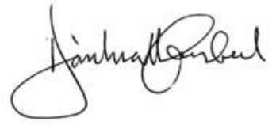

Donald Campbell
CEO

About Us

Who We Are
MG ALBA, Scotland’s Gaelic Media Service, operates the Gaelic multiplatform media service BBC ALBA in partnership with the BBC. We are also responsible for FilmG and, in partnership with other bodies, LearnGaelic and SpeakGaelic.
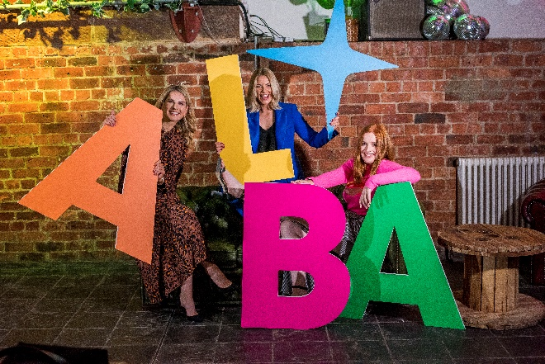
Our Operational Plan for 2021/22 contains important information about our aims and objectives for the previous year.
Where We Are
We are based in Stornoway, with a presence in Glasgow and Inverness.
Our Staff & Board
We employ 43 staff and have a Board of 9 members.

Working Environmnent
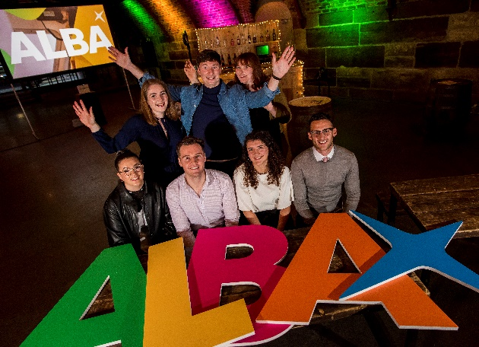
We work with an honest, open, interactive and collaborative approach. Everyone in our team is treated as an equal whose opinion counts. We all share as much information as possible so that all colleagues know how we are performing, how we all contribute to that and how we can be even better at what we do.
We are also proud to have achieved external accreditation including; listing on the Broadcast Best Places to Work in TV for the past five awards, the Platinum Award by Investors in People, and the Gold Award for Investors in Young People. We are committed to ensuring the best health and wellbeing for our people and work with the Healthy Working Lives Awards and Investors in People We Invest In Wellbeing to achieve this.
Corporate Social Responsibilities
As an organisation, we are fully committed to our Corporate Social Responsibilities in a variety of ways including through our Environmental Policy, our Recruitment Policy and in-kind contributions to the community and charitable organisations. We regularly provide free of charge expertise and equipment to local fundraising events, charity balls, quiz evenings, awards ceremonies, and also assist with the production of charity promotional videos, coverage of charity sporting events, cultural and educational workshops and film/Mod events.
brands communication manager POST
Background
Gaelic media, like all other media, is undergoing significant change. This is both challenging and energising.
This is an exciting opportunity for an experienced marketing or communications professional to join the team at MG ALBA in the role of Brands Communication Manager. Based within our Content Team, the postholder will contribute significantly to the effective engagement of all MG ALBA content brands with the people and audiences that we serve.

The postholder will also be responsible for making significant progress on achieving, with partners, a national consensus on the positive value of Gaelic and Gaelic media and, with partners, to ensure maximum exposure of and engagement with Gaelic media content and brands.

People
Our ideal applicant will possess these core qualities:
- Willingness to be part of a busy, dynamic and growing team
- Excellent interpersonal and communication skills
- Be motivated and a self-starter
- Strong influencing and analytical skills
- Excellent understanding of social media platforms and analytics in reaching audiences effectively
- Willingness to commit to learning on the job, supported by professional development and external qualifications
The Role
The Brands Communication Manager will report to the Director of Multiplatform Content. Core elements of the role include:
- Plan, manage, and ensure delivery and curation of Gaelic media promotional materials for content brands including BBC ALBA, FilmG, LearnGaelic, SpeakGaelic and an upcoming ugc aggregation initiative, Càrn;
- Co-ordinate BBC ALBA content promotion activities, liaising with BBC ALBA Head of Service, BBC ALBA Digital Hub and suppliers;
- Manage the BBC ALBA supplier promotional deliverables, including imagery delivery; this will include regular diarised contact with suppliers;
- Promote BBC ALBA and other brands’ content to appropriate media outlets and digital platforms, including using digital platforms’ data analytics to inform promotion;
- Creation of high quality written materials for web, social media, print, where required etc.;
- Speaking roles as an ambassador of MG ALBA and for Gaelic media;
- FilmG Project management

Our Values
Our values are the key principles that guide the work we do. They determine our priorities and underpin the way we operate in all that we do.
Creativity
- We enable the creation of high-quality Gaelic content

Audience
- We are informed and inspired by our audience

Ambition
- We strive for and deliver excellence

Partnership
- We achieve through collaboration

Respect
- We listen; we encourage; we are fair

APPLICATION INFORMATION
Key Dates

Applications Open 13 December 2021
Closing Date 7 January 2022, 12pm
Interviews 17 January 2022

Selection Process

The selection process is outlined in the MG ALBA Recruitment Policy.

Selection Panel

Director of Multiplatform Content, Director of Strategy & External Affairs, BBC Head of Service, supported by the HR Adviser.

Equal Opportunities Monitoring

We are an equal opportunities employer and conduct monitoring on all recruitment and employment data. Please complete the enclosed monitoring form which is in line with current GDPR legislation.

Disabled Applicants

Applications from disabled applicants are welcome and we participate in the Guaranteed Job Interview Scheme for applicants self-assessed as having a disability and who meet the minimum essential criteria for a job vacancy and to consider them on their abilities.

Referees

2 referees will be required to be contacted upon acceptance of a conditional offer of employment. We will not contact referees without your consent.

Relationship to Board Member / Officer / Conflict of Interest

Relationships to board or staff members, or any actual or perceived conflicts of interest should be disclosed in the application.

GDPR

Personal data contained with your job application will be processed, retained and archived/destroyed in line with MG ALBA’s Privacy Notice.

MAIN TERMS AND CONDITIONS OF EMPLOYMENT SUMMARY
Grade Grade D3
Salary £36,252-£39,526 per annum

Annual Leave 25 days + 12 days public holiday

Pension Defined Contribution Pension Scheme, MG ALBA contributes 10% of the basic annual salary, rising to 15% if the employee makes a contribution of 5%

Death in Service 4 x Annual Salary

Other Benefits To encourage healthy lifestyles we offer a paid gym membership. We have family friendly & flexible working practices and offer a childcare voucher scheme

Occupational Sick Pay Scheme

Up to two years' service | 1-month full pay and 1 month half pay, in a rolling 12-month period
After 2 years' service | 2 months' full pay/2 months' half pay in a rolling 12-month period
After 3 to 4 years' service | 3 months' full pay/3 months' half pay in a rolling 12-month period
After 5 years' service | 4 months' full pay/4 months' half pay in a rolling 12-month period

Learning & Development

Each employee is required to have a Learning and Development plan which will enable them to become more effective in their job and fulfill their annual job objectives. Professional qualifications are encouraged.
Gaelic

Gaelic is the working language of MG ALBA. This post requires a strong level of proficiency in the language. Support will be given to all candidates who wish to further develop their engagement with Gaelic.
Further Information

For an informal discussion about any aspect of this role please contact hr@mgalba.com and we will arrange for a call at a mutually convenient time.

JOB DESCRIPTION
Job Title | Brands Communication Manager | Grade | D3 | Weekly Hours | 37
Base | Remote + Office bases Glasgow/Stornoway | £36,252-£39,526
Objective | To ensure the effective engagement of MG ALBA content brands with the people and communities each serve, making significant progress on achieving, with partners, a national consensus on the positive value of Gaelic and Gaelic media and, with partners, to ensure maximum exposure of and engagement with Gaelic media content and brands. To ensure the project management of FilmG is executed successfully, achieving the competition objectives.
Accountable to | Director of Multiplatform Content
Responsible for | - Communications management for MG ALBA content brands including:  BBC ALBA, FilmG, LearnGaelic, SpeakGaelic and upcoming ugc aggregation initiative, Càrn  - Management of BBC ALBA supplier promotion deliverables including high-impact imagery for use across platforms.  - Project management of FilmG, including budget management for competition and event.  - Budgets (as agreed)  - Line managing Digital Engagement Officer
Working relationships | The post holder also delivers to the Chief Executive and works closely with the Director of Strategy & External Affairs, BBC ALBA Head of Service and BBC ALBA Digital Hub. The post holder must have excellent internal working relationships with the Senior Management Team, BBC ALBA Content Team and BBC ALBA suppliers. They must also be able to work effectively and efficiently with external advisers, BBC colleagues, stakeholders and media.
Key result areas | The post holder ensures that:  - delivery and curation of Gaelic media promotional materials for all content brands including BBC ALBA, FilmG, LearnGaelic, SpeakGaelic and Càrn is planned and managed;  - all content brand promotion activities - which on BBC ALBA will include liaison with BBC ALBA Head of Service, BBC ALBA Digital Hub and suppliers - is planned, managed and delivered;  - all brands’ promotional initiatives are data driven, including target audience segmentation  - data analysis is undertaken (and/or secured from BBC colleagues and suppliers) of key target platforms for audience promotion. This includes working with suppliers to ensure their social media promotion is maximised.  - management of suppliers’ promotional deliverables (including highest standard of compelling imagery) is undertaken rigorously, including regular reminders to suppliers on such deliverables  - the promotional resources available to Gaelic media are effectively co-ordinated;  - that forward planning of critical media moments is effectively co-ordinated;  - the resources of the organisation and partners are harnessed in order to respond to emerging issues promptly and effectively in the public domain;  - technology is used effectively as communications and management tools;  - staff and board enjoy high levels of visibility and awareness of things that matter to them.  - FilmG is successfully delivered meeting the high standards of engagement and development that are outlined in its objectives, and that the delivery partner delivers on budget, effectively, for both the competition and the event.
Key tasks | The post holder must fulfil the following:  - Plan, manage, and ensure delivery and curation of Gaelic media promotional materials for content brands including BBC ALBA, FilmG, LearnGaelic ,SpeakGaelic and Càrn;  - Co-ordinate BBC ALBA content promotion activities, liaising with BBC ALBA Head of Service, BBC ALBA Digital Hub and suppliers;  - Manage the BBC ALBA supplier promotional deliverables, including imagery delivery; this will include regular diarised contact with suppliers;  - Promote BBC ALBA content to appropriate media outlets;  - Create high quality written materials for web, social media, print, where required etc.;  - Speak with high impact in private and public domains on behalf of MG ALBA and as ambassador for Gaelic media;  - Deliver quarterly reports to management;  - Project management lead in co-ordination of FilmG project, including budget management and fulfilment of competition objectives
Risk | - Under the MG ALBA Model of Risk Management, Risk is seen as everyone’s business.  - All postholders, therefore, have a responsibly to consider risk at all times including a responsibility to report/discuss any risks, perceived risks, risk mitigations and/or issues to their Line Manager or any Corporate Risk Group members.  - Up to date monthly Risk Registers will be available to view on SharePoint and postholders are encouraged to read these on a regular basis.  - All postholders should be prepared to consider Risk at staff appraisals and/or job chat times.
Core skills | Essential  - Relevant qualifications and / or equivalent experience;  - Aptitude, attitude and a proven track record in communications and / or stakeholder engagement;  - Excellent interpersonal and communication skills (oral and written) in both Gaelic and English;  - Good analytical skills, able to put complex and nuanced arguments in simple but effective messages;  - Ability to analyse digital platforms’ analytics and understand how to effectively utiltise these;  - Ability to create high quality documents and presentations under pressure;  - Good presentation and public speaking skills;  - Able to manage own time and exercise good judgement in prioritising according to urgency and priority;  - Strong team player, able to work consultatively and to manage upwards;  - Excellent organisational and planning skills;  - Ability to build and maintain excellent working relationships internally and externally;  - Capable of working to tight deadlines and under pressure, possessing resilience but able to work simultaneously with calmness and energy;  - Ability to anticipate issues in advance, providing solutions, recommendations and escalation in a timely manner;  - High level of commitment to personal and professional development.  Desirable  - Professional experience in broadcasting  - Personal and professional knowledge of, and commitment to, digital media communications (for example, social media) and tools (such as Word, PowerPoint and CRM solutions)  - Ability to author messages in Gaelic  - Research and proof-reading skills
Time horizon | Permanent

