JOB DESCRIPTION & APPLICATION PACK

Post | Reporting To
SpeakGaelic Online Learning Associates | Online Learning Digital Editor
Office Base | Remote Working
Closing Date for all Applications | 4 May 2021, 12pm
Interviews | 17 May 2021, via Zoom

19 April 2021

Dear Applicant

APPLICATION FOR EMPLOYMENT – SpeakGaelic Online Learning Associates

Thank you for your interest in applying for our newly created posts working within our growing Online Learning team. These posts support a number of changes MG ALBA is making to take advantage of the opportunities arising with the fast pace of change in the media sector. We are a looking for two individuals who are fully committed to collaborative, digital-first work practices and to continued professional development.

We have pleasure in enclosing this application pack for this vacancy.

To apply, please submit a covering letter and your CV detailing your skills, knowledge and capabilities, paying particular attention to the Job Description and Person Specification requirements. We welcome hearing about your competency and experiences from both employed and voluntary roles. If you would like an informal discussion on any of these roles, please contact Claire Macleod, HR Adviser on hr@mgalba.com and we will arrange for a call at a mutually convenient time.

You should submit your application by 12pm on Tuesday 4 May 2021 to hr@mgalba.com. Any applications received after this date unfortunately cannot be considered.

Interviews will be held via Zoom on Monday 17 May 2021.

Le dùrachd

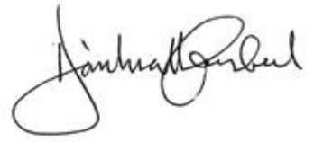

Donald Campbell
CEO

About Us
Who We Are
MG ALBA, Scotland’s Gaelic Media Service, operates the Gaelic television channel BBC ALBA in partnership with the BBC. We are also responsible for FilmG, in collaboration with Cànan Graphics Studio, and we deliver LearnGaelic in partnership with the BBC, Bòrd na Gàidhlig, Sabhal Mòr Ostaig and Bòrd na Ceiltis (Alba).
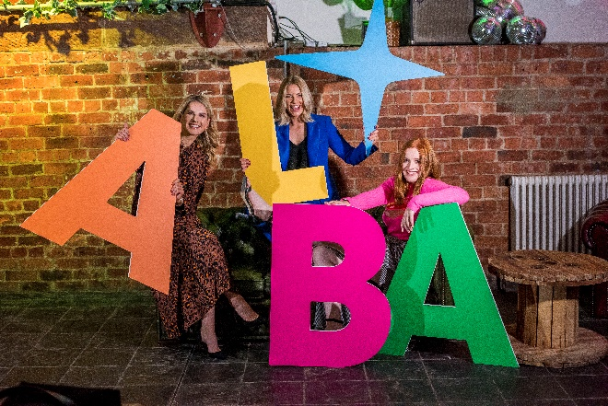
Our Operational Plan for 2020/21 contains important information about our aims and objectives for this year.
Where We Are
We are based in Stornoway, with a presence in Glasgow and Inverness. As a repsonse to the Covid-19 pandemic, we have successfully transitioned to remote working and this option will continue to be available to the successful candidate. We are keen to speak with candidates who reside in Gaelic-speaking / learner communities and can access either our own office sites or creative / community hubs to attend regular meetings and workplace discussions.
Our Staff & Board
We employ 43 staff and have a Board of 9 members.

Working Environmnent
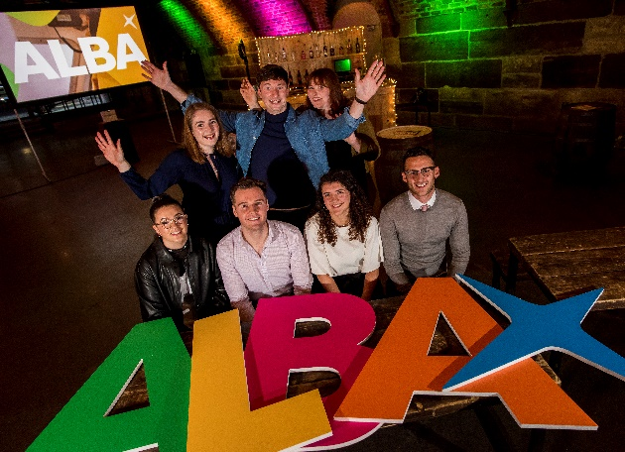
We work with an honest, open, interactive and collaborative approach. Everyone in our team is treated as an equal whose opinion counts. We all share as much information as possible so that all colleagues know how we are performing, how we all contribute to that and how we can be even better at what we do.
We are also proud to have achieved external accreditation including; listing on the Broadcast Best Places to Work in TV for the past five awards, the Silver Award by Investors in People, and the Gold Award for Investors in Young People. We are committed to ensuring the best health and wellbeing for our people and work with the Healthy Working Lives Awards to achieve this.
Corporate Social Responsibilities
As an organisation, we are fully committed to our Corporate Social Responsibilities in a variety of ways including through our Environmental Policy, our Recruitment Policy and in-kind contributions to the community and charitable organisations. We regularly provide free of charge expertise and equipment to local fundraising events, charity balls, quiz evenings, awards ceremonies, and also assist with the production of charity promotional videos, coverage of charity sporting events, cultural and educational workshops and film/Mod events.
OUR NEW POSTS
Background
Gaelic media, like all other media, is undergoing significant change. This is both challenging and energising.
These new posts will work to strengthen the work of the newly created SpeakGaelic brand.
The main objectives of the posts are to populate the SpeakGaelic website and curate content for social media content production and publishing.
Candidates should have strong editorial and organisational skills, attention to detail and be able to work effectively as part of a team.
People
Our ideal applicants will possess these core qualities:
- Willingness to be part of a busy, dynamic and growing team
- Excellent interpersonal and communication skills
- A keen interest in digital media, especially social media
- Be a strong team player
- Willingness to commit to learning on the job, supported by professional development and external qualifications
The Roles
The Online Learning Associates will report to the Online Learning Digital Editor. Core elements of the role include:
- Championing the SpeakGaelic brand
- Website editing
- Social Media content curation and scheduling
- Contributing to SpeakGaelic quizzes and other interactive content

APPLICATION INFORMATION
Key Dates

Applications Open 19 April 2021
Closing Date 4 May 2021
Interviews 17 May 2021, via Zoom

Selection Process

The selection process is outlined in the MG ALBA Recruitment Policy.

Selection Panel

Line Manager and SpeakGaelic Colleagues, supported by the HR Adviser.

Equal Opportunities Monitoring

We are an equal opportunities employer and conduct monitoring on all recruitment and employment data. Please complete the enclosed monitoring form which is in line with current GDPR legislation.

Disabled Applicants

Applications from disabled applicants are welcome and we participate in the Guaranteed Job Interview Scheme for applicants self-assessed as having a disability and who meet the minimum essential criteria for a job vacancy and to consider them on their abilities.

Referees

2 referees will be required to be contacted upon acceptance of a conditional offer of employment. We will not contact referees without your consent.

Relationship to Board Member / Officer / Conflict of Interest

Relationships to board or staff members, or any actual or perceived conflicts of interest should be disclosed in the application.

GDPR

Personal data contained with your job application will be processed, retained and archived/destroyed in line with MG ALBA’s Privacy Notice.

MAIN TERMS AND CONDITIONS OF EMPLOYMENT SUMMARY
Grade Grade B1-7

Salary £22,742 per annum

Annual Leave 25 days + 12 days public holiday

Pension Defined Contribution Pension Scheme, MG ALBA contributes 10% of the basic annual salary, rising to 15% if the employee makes a contribution of 5%

Death in Service 4 x Annual Salary

Other Benefits To encourage healthy lifestyles we offer a paid gym membership. We have family friendly & flexible working practices and offer a childcare voucher scheme

Occupational Sick Pay Scheme

Up to two years' service | 1-month full pay and 1 month half pay, in a rolling 12-month period
After 2 years' service | 2 months' full pay/2 months' half pay in a rolling 12-month period
After 3 to 4 years' service | 3 months' full pay/3 months' half pay in a rolling 12-month period
After 5 years' service | 4 months' full pay/4 months' half pay in a rolling 12-month period

Learning & Development

Each employee is required to have a Learning and Development plan which will enable them to become more effective in their job and fulfill their annual job objectives. Professional qualifications are encouraged.
Gaelic

Gaelic is the working language of MG ALBA. This post requires a strong level of proficiency in the language. Support will be given to all candidates who wish to further develop their engagement with Gaelic.
Further Information

For an informal discussion about any aspect of this role please contact hr@mgalba.com and we will arrange for a call at a mutually convenient time.

JOB DESCRIPTION
Job Title | Online Learning Associate | Grade | B1-7 | Weekly Hours | 37
Objective | Ensures the SpeakGaelic website, app and social media are populated with relevant and compelling content that users are seeking and that adheres to compliance, technical and brand documentation.
Accountable to | Online Learning Digital Editor
Responsible for | - Populating SpeakGaelic website and social media feeds  - Undertaking research  - Editing and transcribing audio and video  - Using SpeakGaelic product knowledge to curate content for social media  - Working with the Online Learning team on the SpeakGaelic and LearnGaelic brands  - Admin support for the SpeakGaelic Project Board
Working relationships | The job holder works as a member of the MG ALBA Online Learning team under the direction of the Online Learning Manager & Online Learning Digital Editor and liaising daily with online learning colleagues and third-party providers of educational and broadcast items and other material for digital platforms.
Key result areas | The job ensures that online learning colleagues are supported in content for the learning brands’ digital presence, working to defined KPIs within the multi-platform environment.
Key tasks | Supports Online learning colleagues in developing and maintaining a strong digital media presence. Tasks include:  - Championing the SpeakGaelic brand  - Editing the SpeakGaelic Website  - Editing and transcoding audio and video for the SpeakGaelic website  - Editing images for the SpeakGaelic website and social platforms  - Selecting content for SpeakGaelic quizzes  - Curating and re-creating content for SpeakGaelic social media platforms  - Undertaking peer review  - Editing and scheduling social media feeds  - Supporting Online Learning colleagues with production  - Admin support for the SpeakGaelic Project Board
Time horizon | 2 years fixed term contract of employment

PERSON SPECIFICATION
 | Essential | Desirable
Qualifications / Experience | B2 level of Gaelic across reading, writing, listening and speech | Professional qualifications are desirable but not essential  Aptitude, attitude and a proven track record in both language skills and a passion for digital media
Knowledge | Ability to author messages in Gaelic | Basic editing knowledge  Basic image manipulation  Personal and professional knowledge of, and commitment to, multi-platform development and tools are desirable
Skills | Excellent interpersonal and communication skills (oral and written) in both Gaelic and English;  Strong planning skills; able to work across teams  Strong attention to detail  Able to project manage own time and prioritise effectively;  Strong team player;  High level of commitment to personal and professional development
Language Requirement | Fluent Gaelic speaker
Behavioural | Strong sense of judgement and independence of thought  Strong team player, able to work consultatively and across teams  Integrity  Reliability  Interpersonal & relational skills | Positive ‘Can do’ attitude

